Modified SigPlus

User Manual

# Hardware

### Screen 1: Welcome Screen

Welcome screen. User taps anywhere on screen to begin process

### Screen 2: Name Screen

Visitor enters their complete name. This will show under the “*Name”* column of the Data Grid on the main software screen.

Clear: Clears input screen

OK: Prompts the next screen

**If user tries to hit “OK” without entering any writing, a “Please sign before continuing” screen will load for 2.5 seconds before refreshing the Name screen

### Screen 3: Company Name Screen

Visitor enters their company name. This will show under the “C*ompany”* column of the Data Grid on the main software screen.

Clear: Clears input screen

Ok: Prompts the next screen

### Screen 4: Citizen Screen

The visitor is asked if he/she is a citizen or permanent resident. The answer will be displayed under the “*Citizen?”* Column of the

Yes: Prompts the next screen

No: Prompts the software user (Martha) to enter a chaperone for the visitor

### Screen 5: Visitee Screen

The visitor is asked who they came to visit.

Person checkbox: This will terminate the input process. The data grid will be reloaded and the new input will become visible

Other: This will prompt an extra screen

### Screen 6(Optional): Other screen

The visitor is asked to manually write who they are visiting.

Clear: Clears the input box

OK: This terminates the process. The name will

# Software

### Loading Screen:

Select the Access File (*.accdb) where the information is located and where the new inputs will be stored to.

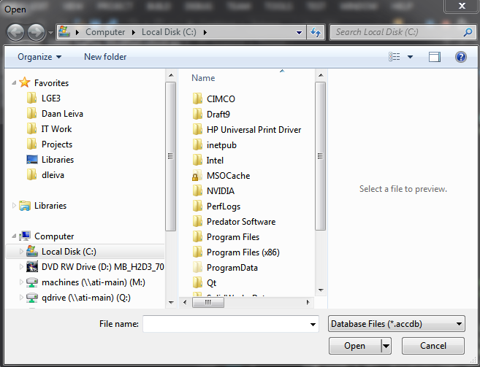

**1z**

1. Only MS Access Database Files are allowed

### Main Screen:

**3**

**1z**

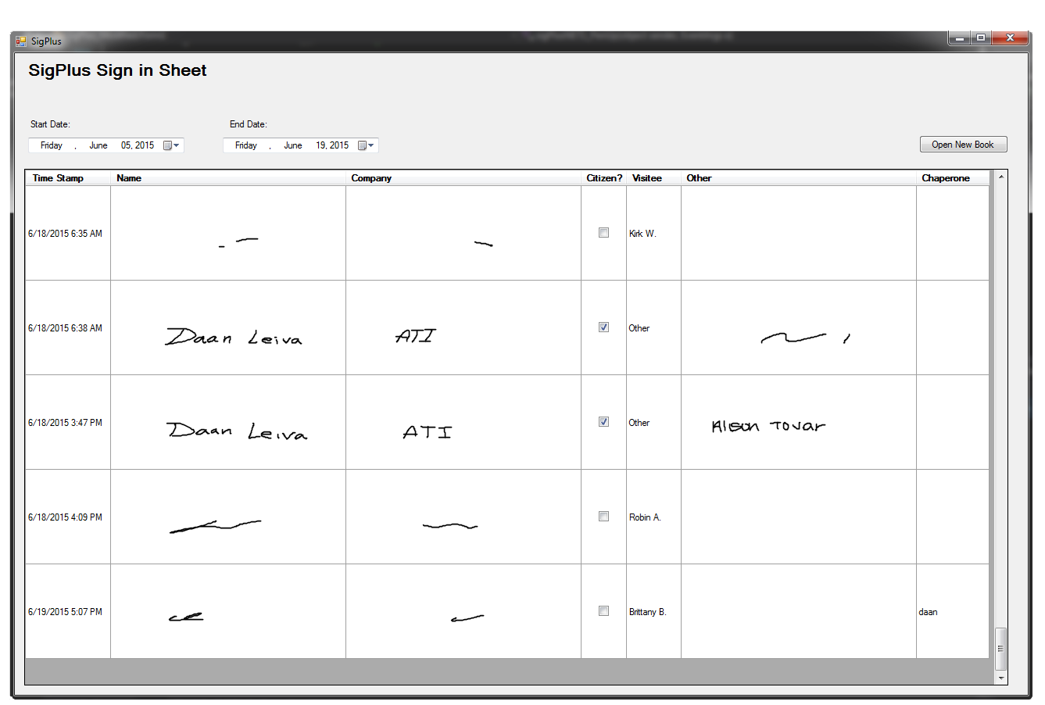

**2**

**Important Items**

1. Date range from which items will be loaded
   1. If new data is input through the hardware (sigPlus tablet), the date range will reset.
   2. The data range is limited to the earliest time stamp and the newest time stamp.
2. Sign in information:
   1. Timestamp: Time at which the information was submitted
   2. Name: Name of the visitor. Input manually. Cannot be empty
   3. Company: Name of the company represented by the visitor. Input manually. Cannot be empty
   4. Citizen: If checked, the visitor is a US citizen or permanent US resident
   5. Visitee: The person who the visitor came to see. Will either be a name (if listed on the sigPlus) or “Other”
   6. Other: If the name of the person visited is not listed on the sigPlus, the visitor can manually enter the name here after selected “Other”
   7. Chaperone: If the visitor selected the “No” checkbox for “Being a US citizen or US permanent resident” then the software user(Martha) will be prompted to assign a chaperone to the visitor.
3. Open New Book
   1. Software user can access a new *Access* notebook
   2. This is in case separate instances are used